**4 Pcs Calligraphy Islamic Photo Frame set**

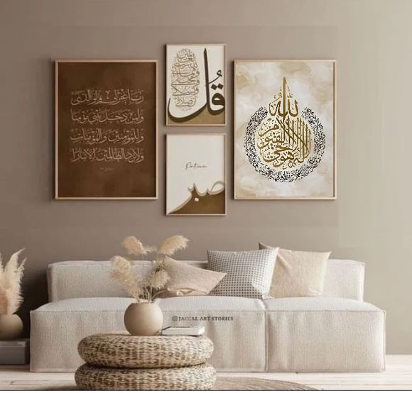The 4 Pcs Calligraphy Islamic Photo Frame Set is a stunning collection that brings the beauty and depth of Islamic art into your home. Each frame in the set features beautifully crafted Arabic calligraphy, often depicting verses from the Quran, names of Allah, or quotes from the Prophet Muhammad (PBUH). These frames are designed with intricate details, blending traditional Islamic motifs with a modern aesthetic, making them perfect for any interior style, from contemporary to classic. Made from durable materials like wood or resin, the frames offer both longevity and elegance. This set is ideal for creating a spiritual ambiance in living rooms, prayer spaces, or study areas, providing a meaningful way to display cherished memories or sacred artwork. The 4-piece arrangement allows for flexibility in display, offering a cohesive, serene atmosphere while honoring Islamic heritage and culture.